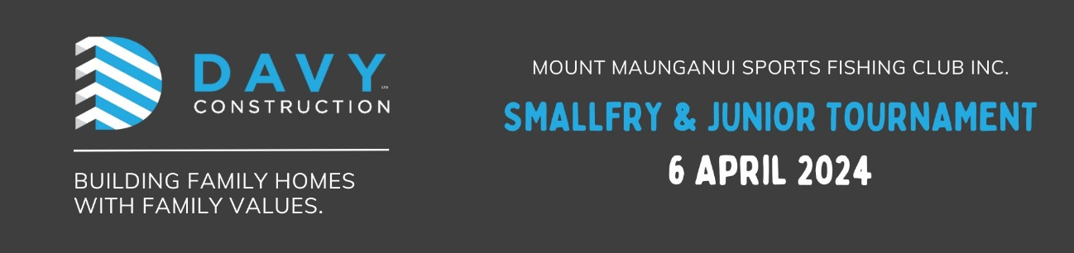
All fish must be caught in accordance with MMSFC, NZSFC and MPI fishing rules.
Briefing | Friday 5th April 2024 – 7pm – compulsory
Fishing Area | Chart 54, All Rotorua Lakes
Species | Trout  Trevally  Snapper  Kahawai  All other species
Minimum Weights | As per MPI legal size limits  Maximum of 3 fish per species per person to be presented for weigh in
Fishing Times | Saturday 6am until final weigh in time
Weigh In | Saturday 6th April – 3.30pm to 5pm  Catch cards are compulsory and must be in weighmasters hands by Saturday 5pm
Prizegiving | Saturday 6th April – 6pm
Prizes | Small Fry section – 1st and 2nd in all species, Average weight, Mystery weight  Junior Section – 1st and 2nd in all species, Average weight, Mystery weight  One prize per person per species
Entry Fee | $5 per angler Small Fry (10 years & under); Junior (11 to 16 years)  Non member - $5 extra per angler
Important Note | The skipper of the boat is always responsible for ensuring the area, weather and sea conditions are satisfactory for the safe use for the craft they are using
Enquiries | Shirl Baker 027 656 8852; shirl@gorebaker.co.nz

You can pay by Direct Credit to MMSFC bank account 03-0374-0154303-00
Mount Maunganui Sport Fishing Club Inc. |  |  |  | SMALL FRY & JUNIORS  6th April 2024
 | Angler’s Name |  | Membership  Number |  | SMALLFRY  10 & under  Entry Fee  $5 |  | JUNIOR  11 to 16 yrs  Entry Fee  $5 | Non  Member  $5 extra | Total Paid
1
2
3
4
5
6
Team Captain |  |  |  |  | Total Paid
Address:
Phone: |  |  |  |  | Email:
Call Sign |  |  |  |  | Boat Name

